CS 255 System Design Document Template
By: Robert Mayweather Jr

UML Diagrams

UML Use Case Diagram
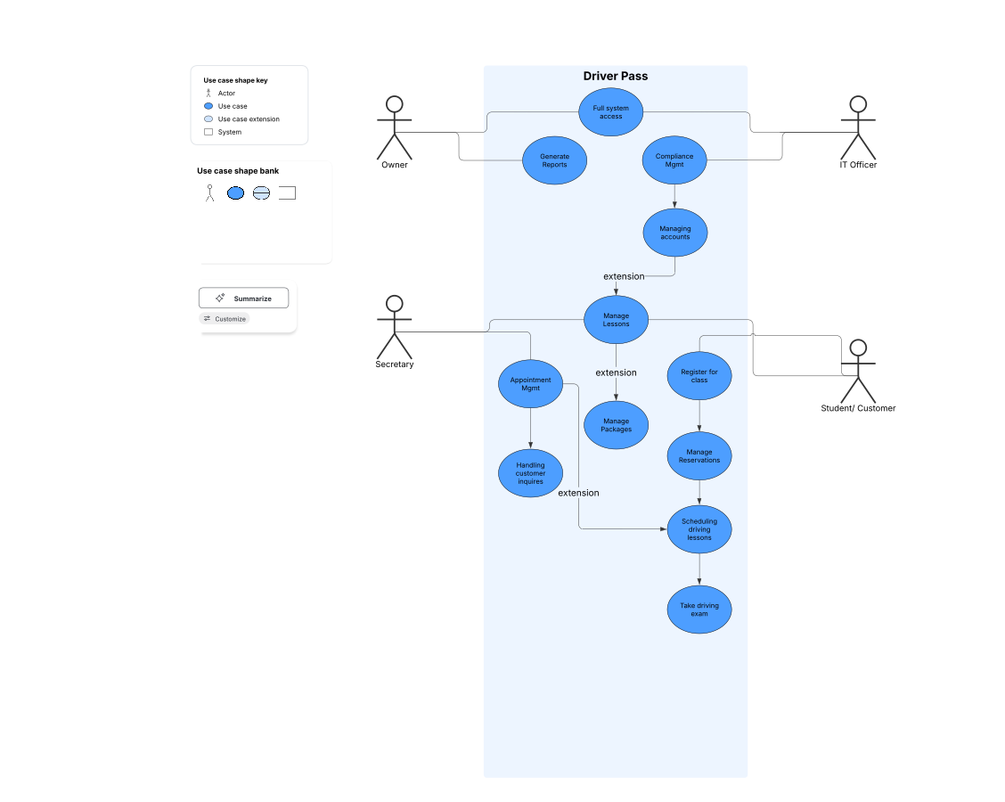

UML Activity Diagrams
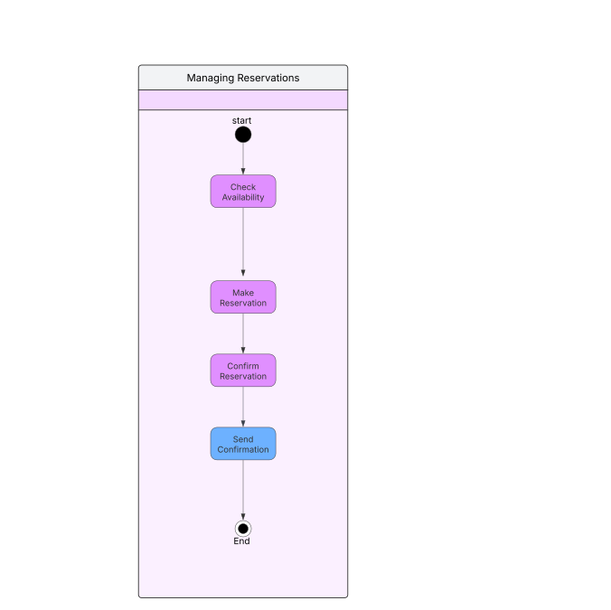

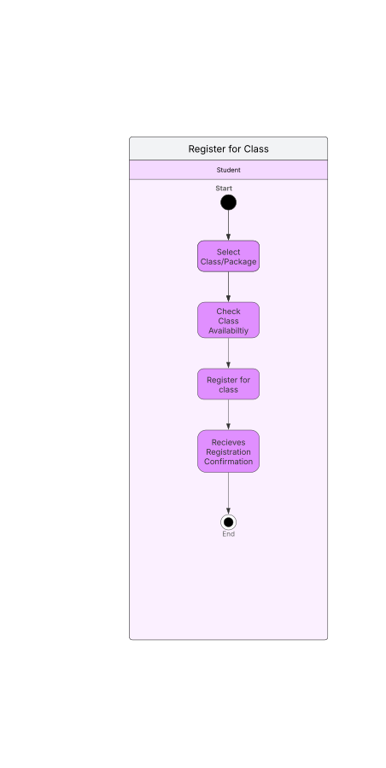

UML Sequence Diagram

Making Reservations
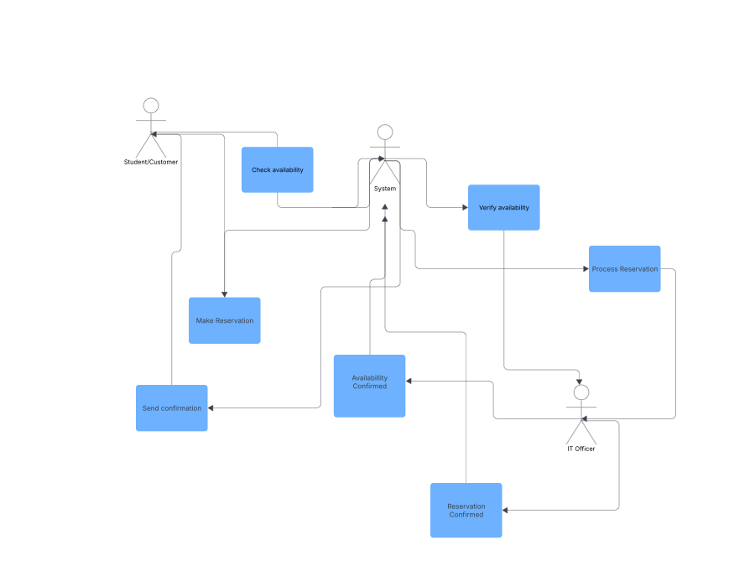

UML Class Diagram
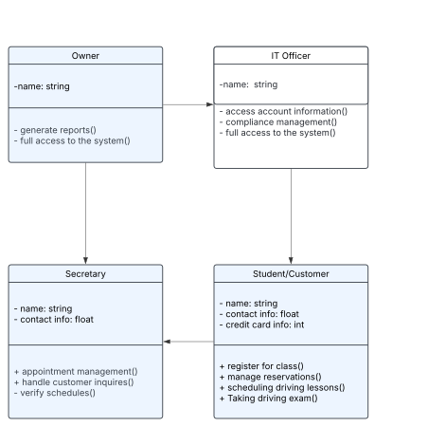

Technical Requirements

For the DriverPass system, I need servers for hosting the website, managing the database, and backing up data, plus desktops, laptops, and mobile devices for everyone using the system. On the software side, I'll want server and client operating systems, web server software like Apache or Nginx, a database system like MySQL or PostgreSQL, and programming languages for both the backend (Java, Python, Node.js) and frontend (HTML, CSS, JavaScript). Development tools like Visual Studio Code and Git are essential, along with security software for encryption and protection.

For infrastructure, cloud services like AWS, Azure, or Google Cloud are great for hosting, storage, and backups. I'll need a fast internet connection and VPN for secure remote access. Regular backups and a disaster recovery plan are key to keeping data safe. Security measures include role-based access control, multi-factor authentication, data encryption, and HTTPS for secure communication. Monitoring and logging tools help track user activities and system events, ensuring everything runs smoothly for the Owner, IT Officer, Secretary, and Student/Customer.

